Chapter 8, Problem 6.

In the circuit of Fig. 8.67, find:

(a) v_{R}(0⁺) and v_{L}(0⁺),

(b) dv_{R}(0⁺)/dt and dv_{L}(0⁺)/dt,

(c) v_{R}(∞) and v_{L}(∞).

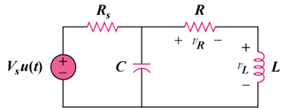

Figure 8.67
For Prob. 8.6.

